**Exercise: Improving report cohesiveness**

**Introduction**

By now, you should have a good understanding of color theory, the use of color in visual design, positioning, scale of information, and information density. These concepts form the basis of report cohesiveness in Microsoft Power BI. In this exercise, you will apply your knowledge in an end-to-end scenario by using Microsoft Power Query to create a report that connects to multiple data sources and has complex visualization elements. You’ll improve its cohesiveness by considering color, scale, positioning, and information density.

**Scenario**

At Adventure Works, you have two main tables for the marketing budgets of the year 2023 for the quarters Q1 and Q2. They are *AdventureWorksMarketing2023-Q1.xslx* and *AdventureWorksMarketing2023-Q2.xlsx*.

Your manager, Adio Quinn, assigns you the task of creating reports that show a detailed list of the quarterly budgets and the budgets per category in a pie chart. Your objective is to enhance the color scheme, positioning, scale, and overall cohesiveness of the report.

This exercise aims to assist you in understanding how to improve the color, position, scale, and cohesiveness of the report.

By the end of this exercise, you’ll understand how to use table and pie chart visualization tools, use of colors, and positioning and scaling techniques to improve the cohesiveness of the report.

Open Power BI and follow the steps below to complete the exercise.

**Step 1: Download files**



[ImprovingReportCohesiveness](https://d3c33hcgiwev3.cloudfront.net/G613uoV2RsGE2ITBZZ2GMA_92422bbab42c472280f922c7484266e1_ImprovingReportCohesiveness.pbix?Expires=1712188800&Signature=NlK2OtwBSXJtSVumuWz-rNgE73lSlrnSHKXswIarRaJhvwgkAHwc7oQA49~cD7UDy5~c1WDokd5Y4jhfiKmxOxSD0Q0BVil2UIm3r-PGISde5za2VeQEFQkktlSaWCf8OOljffxjBmrsXF5TIotmV4tejkdnIMfqoc4ADwPoZSw_&Key-Pair-Id=APKAJLTNE6QMUY6HBC5A" \t "_blank)

[PBIX File](https://d3c33hcgiwev3.cloudfront.net/G613uoV2RsGE2ITBZZ2GMA_92422bbab42c472280f922c7484266e1_ImprovingReportCohesiveness.pbix?Expires=1712188800&Signature=NlK2OtwBSXJtSVumuWz-rNgE73lSlrnSHKXswIarRaJhvwgkAHwc7oQA49~cD7UDy5~c1WDokd5Y4jhfiKmxOxSD0Q0BVil2UIm3r-PGISde5za2VeQEFQkktlSaWCf8OOljffxjBmrsXF5TIotmV4tejkdnIMfqoc4ADwPoZSw_&Key-Pair-Id=APKAJLTNE6QMUY6HBC5A" \t "_blank)

1. Download the *ImprovingReportCohesiveness.pbix* file and open it by using **File > Open report > Browse reports** and find the .pbix file you just downloaded. The Power BI data model contains two tables, **Marketing2023-Q1** and **Marketing2023-Q2** representing the total amount and total budget allocated for each product category.
2. Download the *AdventureWorksLogo.jpg*  file and store it for later use.

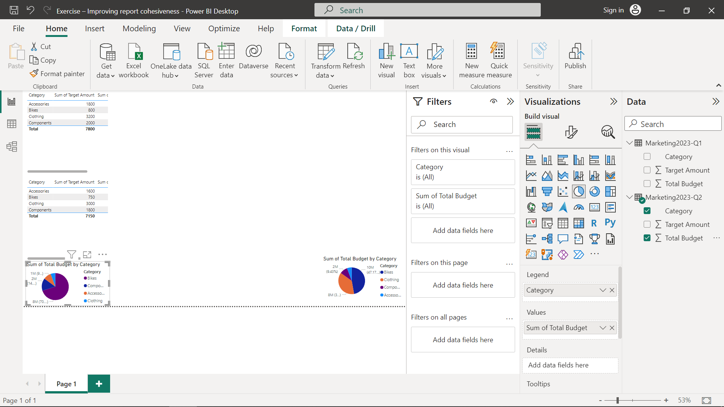

**Step 2: Assess the current design**

1. Identify the improper use of colors and elements that contribute to the cluttered and disorganized appearance of the report.
2. Analyze the information density and identify areas where it can be improved.
3. Note any inconsistencies in positioning, alignment, and visual hierarchy.
4. Place the tables and charts side by side using drag-and-drop.
5. Set the title text of the tables as **Marketing Budget Detail Q1** and **Marketing Budget Detail Q2**.
6. Rename the chart titles as **Marketing Budget 2023-Q1** and **Marketing Budget 2023-Q2**.

**Step 3: Simplify the layout**

1. Remove unnecessary elements and reduce visual clutter.
2. Use white space effectively to create sufficient space between different sections.
3. Ensure a consistent and balanced positioning of elements, aligning them properly.
4. Make sure that visual elements are vertically and horizontally aligned.
5. Leave an empty space between the vertical and horizontal visuals to make the elements more readable.
6. Move the charts slightly to the right to make room for expanding the tables and ensure all fields are visible.
7. Enlarge the charts to make them more prominent and attention-grabbing.

**Step 4: Establish a clear visual hierarchy**

1. Prioritize the most important information and make it visually prominent.
2. Use appropriate font sizes, styles, and colors to guide the viewer's attention.
3. Group related elements together to enhance organization and readability.
4. Add the *AdventureWorksLogo.jpg*  file from the file location that you saved before.
5. Drag the image to position it at the top-left corner and resize it as well.
6. Increase the font size of the table and chart titles to **20**, set them to **Bold,** and select the text color of **Q1** as **Orange**, and **Q2** as **Green**.

**Step 5: Refine and iterate**

* Review the redesigned page and make any necessary adjustments or improvements.

**Tip**: At this point in the design process, you would often seek feedback from colleagues or users to validate the effectiveness of the cohesive design. You might then also continuously refine and iterate the page based on feedback and evolving needs.

**Conclusion**

By following these steps, you can transform a poorly designed page into a cohesive and visually appealing one that effectively communicates information for Adventure Works. You have now successfully completed a cohesive report design by considering color, scale, positioning, and information density using Power BI.

# **Exemplar: Improving report cohesiveness**

**Overview**

In the exercise *Improving report cohesiveness,* you put into practice your understanding of how to use color, scale, positioning, and information density in Power Query.

Your objective for this exercise was to complete the following tasks:

* Download a PowerBI report.
* Assess the current design.
* Simplify the layout.
* Establish a clear visual hierarchy.
* Refine and iterate.

This reading provides a step-by-step guide for completing these tasks, accompanied by screenshots for easy comparison with your own copy.



[ImprovingReportCohesiveness](https://d3c33hcgiwev3.cloudfront.net/G613uoV2RsGE2ITBZZ2GMA_92422bbab42c472280f922c7484266e1_ImprovingReportCohesiveness.pbix?Expires=1712188800&Signature=NlK2OtwBSXJtSVumuWz-rNgE73lSlrnSHKXswIarRaJhvwgkAHwc7oQA49~cD7UDy5~c1WDokd5Y4jhfiKmxOxSD0Q0BVil2UIm3r-PGISde5za2VeQEFQkktlSaWCf8OOljffxjBmrsXF5TIotmV4tejkdnIMfqoc4ADwPoZSw_&Key-Pair-Id=APKAJLTNE6QMUY6HBC5A" \t "_blank)

[PBIX File](https://d3c33hcgiwev3.cloudfront.net/G613uoV2RsGE2ITBZZ2GMA_92422bbab42c472280f922c7484266e1_ImprovingReportCohesiveness.pbix?Expires=1712188800&Signature=NlK2OtwBSXJtSVumuWz-rNgE73lSlrnSHKXswIarRaJhvwgkAHwc7oQA49~cD7UDy5~c1WDokd5Y4jhfiKmxOxSD0Q0BVil2UIm3r-PGISde5za2VeQEFQkktlSaWCf8OOljffxjBmrsXF5TIotmV4tejkdnIMfqoc4ADwPoZSw_&Key-Pair-Id=APKAJLTNE6QMUY6HBC5A" \t "_blank)

**Step 1: Download files**

1. Download the *ImprovingReportCohesiveness.pbix* file and open it by using **File > Open report > Browse reports** and find the .pbix file you just downloaded. You now have four visual elements that lack a defined purpose, with inconsistent positioning and alignment on the page.

2. Download the *AdventureWorksLogo.jpg*  file and store it for later use.

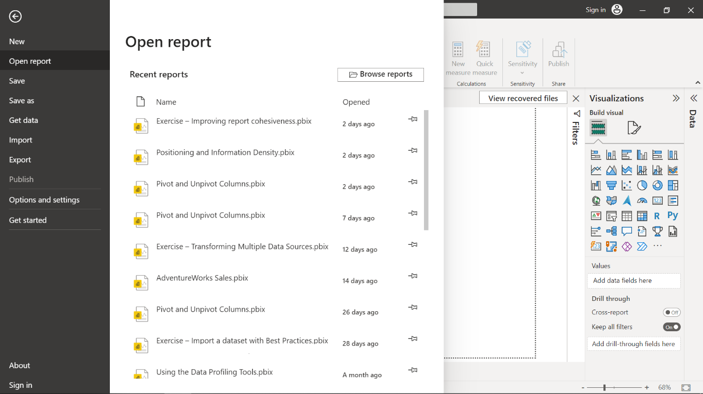

**Step 2: Assess the current design**

1. Identify the elements that contribute to the cluttered and disorganized appearance. Specifically, these are the two pie charts at the bottom of the page.
2. Analyze the information density and identify areas where it can be improved.
3. Note any inconsistencies in positioning, alignment, and visual hierarchy. The two pie charts are located in the bottom left and right corners of the report, and are not the same size.
4. Place the tables and charts side by side by drag and drop. They are now aligned and resized with the corresponding tables.

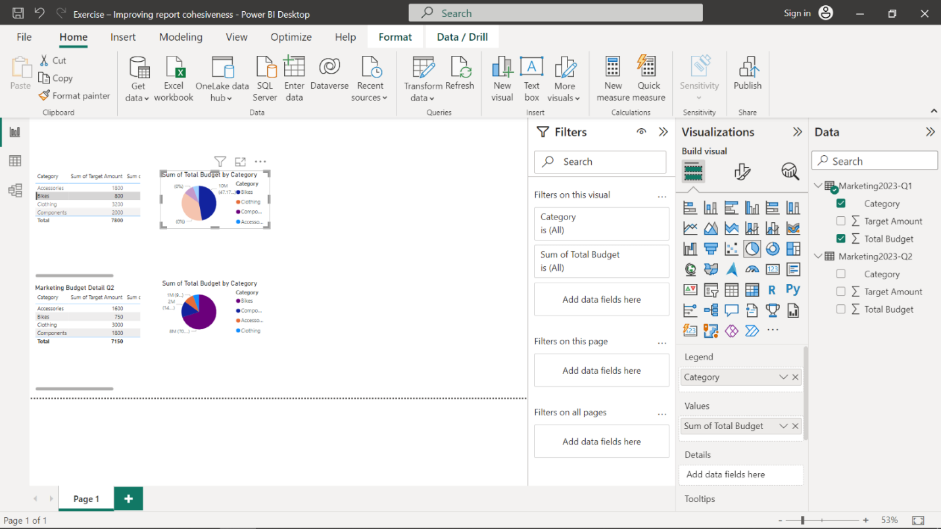

1. Set title text to tables as **Marketing Budget Detail Q1** and **Marketing Budget Detail Q2**respectively to differentiate from each other. To do this, select the first table and then navigate to **Visualizations > Format visual > Visual > General.**Change the text property by typing **Marketing Budget Detail Q1**. Repeat the same for the second table as well, naming it **Marketing Budget Detail Q2**.

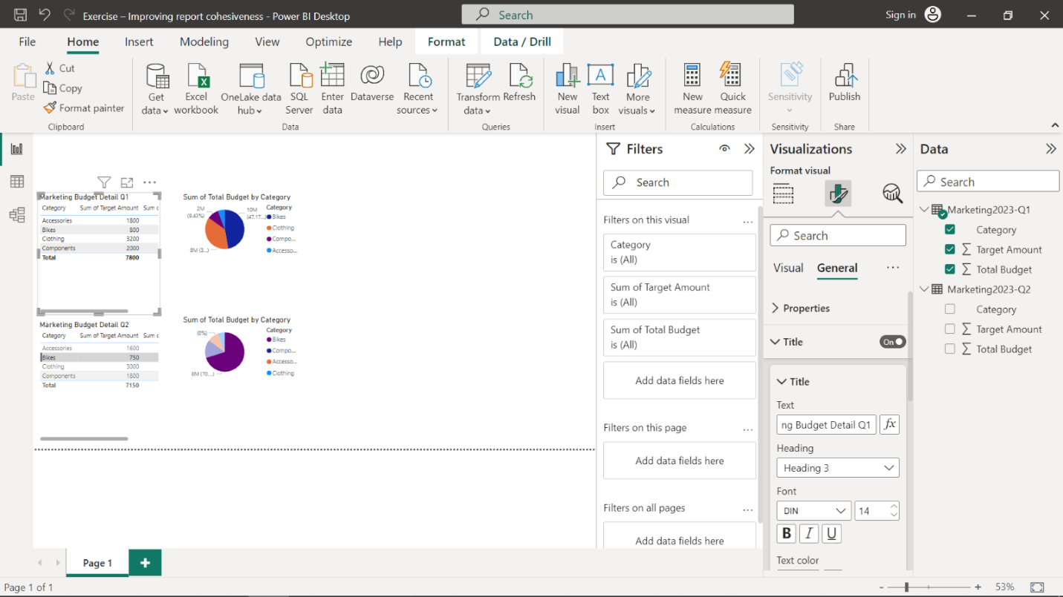

1. Rename the chart titles as Marketing Budget 2023-Q1 and Marketing Budget 2023-Q2 respectively. To do this, select the first chart and then navigate to **Visualizations > Format visual > Visual > General.**Change the text property by typing **Marketing Budget 2023-Q1**. Repeat the same for the second chart as well.

**Step 3: Simplify the layout**

1. Remove unnecessary elements and reduce visual clutter.
2. Use white space effectively to create breathing room between different sections.
3. Ensure a consistent and balanced positioning of elements, aligning them properly.
4. Make sure that the visual elements are vertically and horizontally aligned.

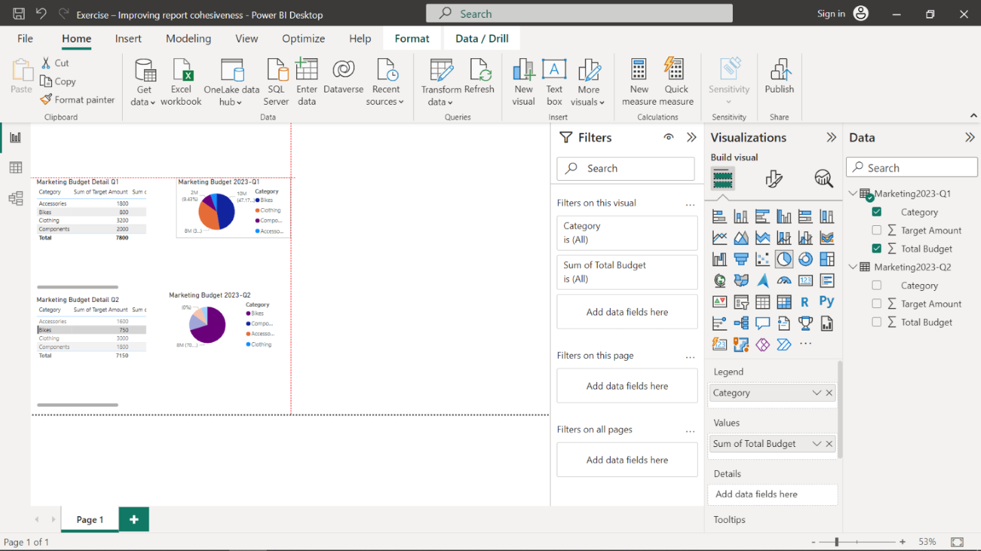

1. Leave an empty space between the vertically and horizontally to make the elements more readable.
2. Move the charts slightly to the right to make room for expanding the tables and ensure all fields are visible.
3. Enlarge the charts to make them more prominent and attention-grabbing. You can use the guide markers to resize it.

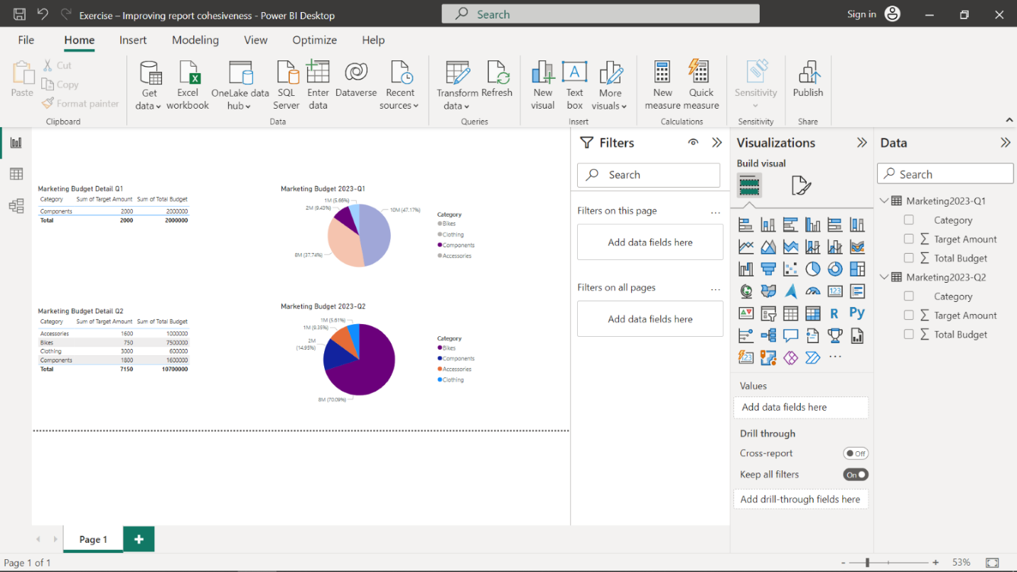

**Step 4: Establish a clear visual hierarchy**

1. Prioritize the most important information and make it visually prominent. This will specifically refer to the pie charts, which will capture the user's attention and draw their eyes to this information.
2. Use appropriate font sizes, styles, and colors to guide the viewer's attention.
3. Group related elements together to enhance organization and readability.
4. To add the company logo, on the **Insert** ribbon tab, inside the **Elements** group, select **Image**. Select the **AdventureWorksLogo.jpg**  file from the file location that you saved before, and then select **Open.**This is done to improve branding and visual appeal.
5. Drag the image to position it at the top-left corner and drag the guide markers to resize it. This keeps the report clean, ensuring the logo does not impeded the information you want users to interact with.

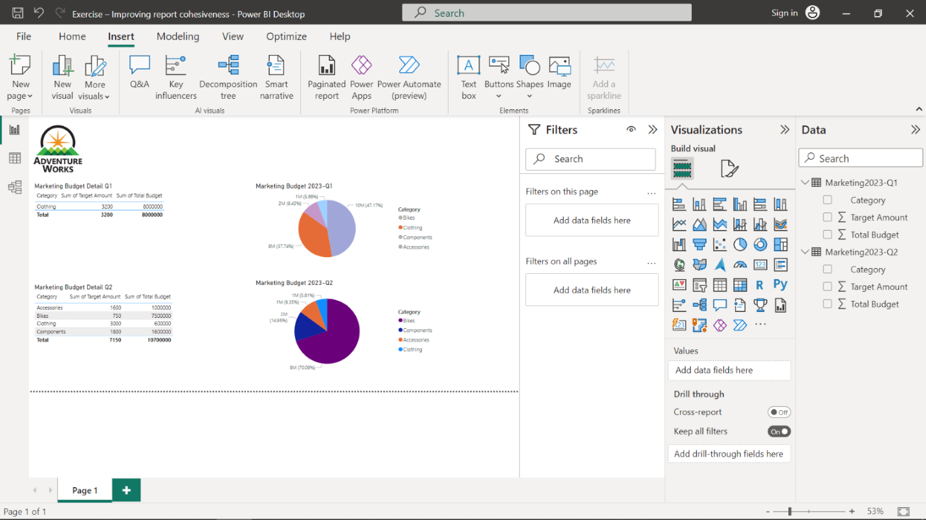

1. Increase the font size of the table and chart titles to **20**, set it to bold and select text color as orange. To do this, select the element and then navigate to **Visualizations > Format visual > Visual > General**. Select font size as **20** in the dropdown, select **B** as Bold, and choose the color. Repeat the same for the other elements as well.

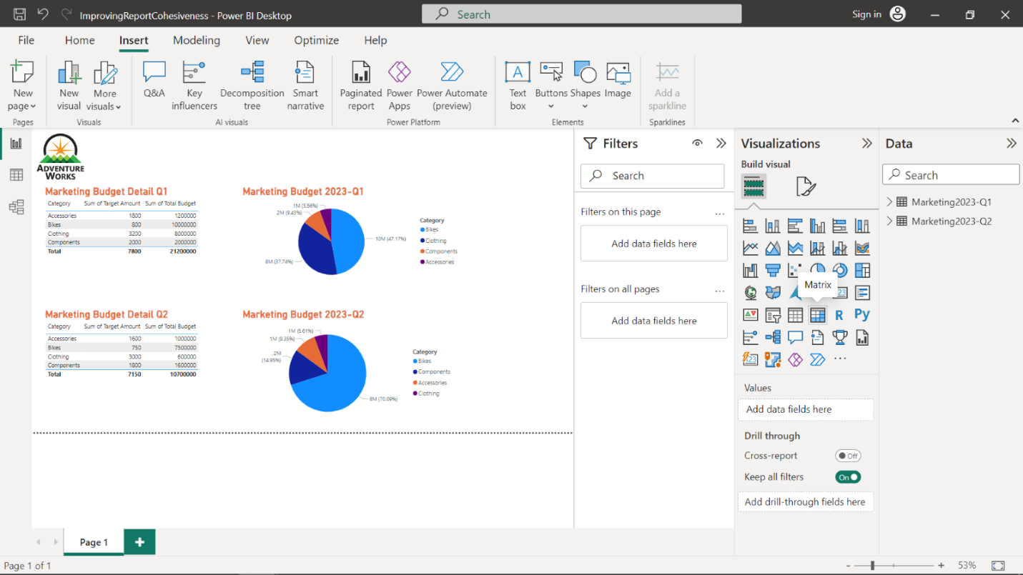

**Step 5: Refine and iterate**

* Review the redesigned page and make any necessary adjustments or improvements.

**Tip:** Seek feedback from colleagues or users to validate the effectiveness of the cohesive design. Continuously refine and iterate the page based on feedback and evolving needs. By following these steps, you can transform a poorly designed page into a cohesive and visually appealing one that effectively communicates information for Adventure Works.

**Conclusion**

Your objective for this exercise was to complete an end-to-end scenario. In this context, you learned how to design a cohesive report by considering color, scale, positioning and information density using Power BI.